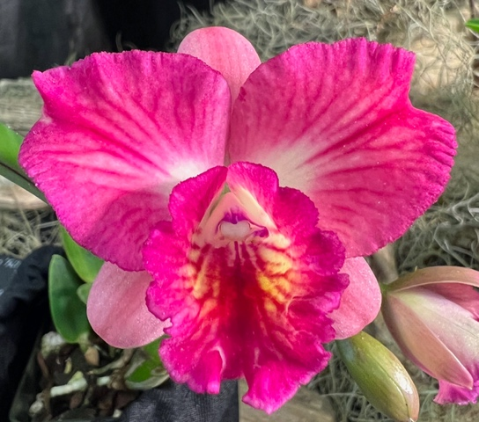
Cattleya Culture Sheet
Cattleyas are among the most popular and iconic of all the orchids. Cattleyas and their related hybrids come in many colors, shapes, forms, sizes and blooming seasons. (With a careful selection of around 20-25 plants, a hobbyist can have cattleyas blooming year-round!) Culture varies only slightly among most of these. Like many other orchids, cattleyas are epiphytes (growing on trees and/or rock surfaces, not in the soil). They have water-storage organs, called pseudobulbs, and large, fleshy roots covered with a spongy, water-retentive velamen allowing them to survive periods of dry weather in between rain events, thus, they need to be potted in free-draining media.
The following is a general guide to basic Cattleya culture:
Light is the most important factor in growing and flowering cattleyas, whether in a greenhouse or in the home. Bright light to some sun should be given to the plants, with no direct sun in the middle of the day. This means an east, shaded south (as with a sheer curtain) or west window in the home, and 50 to 70 percent full sun in a greenhouse (3,000 to 5,000 foot-candles). Leaves should be a medium green color.
Temperatures should be 55 to 60 F at night and 70 to 85 F during the day. Seedlings should have night temperatures five to 10 degrees higher. A 15- to 20-degree differential between day and night is recommended, especially for mature plants. Higher day temperatures can be tolerated (up to 95 F), if humidity, air circulation and shading are increased.
Water and Fertilizer should be considered together as, water carries fertilizer into the root zone. Mature cattleyas need to dry out thoroughly before being watered again. Seedlings need more constant moisture. If in doubt, it's best to wait a day or two until watering. We fertilize with every watering using a weak fertilizer solution of 100 PPM nitrogen; this equates to ½ tsp in a gallon of water. In the summer when days are long and warm and the plants are in active growth, we water more, usually two times a week. However during August we may water up to three times a week. During the cooler months watering once a week is generally satisfactory. Before watering we always check that the potting media has dried out sufficiently. Once a month we leach the pots with plain water twice, about an hour apart, to reduce salt buildup. Water below 50ºF can injure plants and roots, as will “soft” water.
Humidity should be maintained between 50 and 80 percent for cattleyas. This can be provided in the home by placing the plants on trays of gravel, only partially filled with water so that the plants do not sit in the water. Air should always be moving around the plants to prevent fungal or bacterial disease, especially if high humidity or cool temperatures exist.
Potting is necessary when the rhizome of the plants protrudes over the edge of the pot or the potting medium is beginning to break down and drain poorly (usually after two to three years). We wait to repot until the new roots just begin to sprout from the rhizome. Mature cattleyas are usually potted in coarser potting material than are seedlings. Until a plant has at least six mature pseudobulbs, it generally should be put into a larger pot and not divided. If dividing a plant, three to five pseudobulbs per division are required. Do not overpot! Select a pot that will allow for approximately two years of growth before crowding the pot. Keep the plant humid, shaded and dry at the roots until new root growth is seen.

